**How to Use ModelMapper in Spring Boot with Example Project?**

Last Updated : 21 Dec, 2023

ModelMapper is an intelligent, refactoring safe object mapping library that automatically maps objects to each other. The goal of ModelMapper is to make object mapping easy, by automatically determining how one object model maps to another, based on conventions. Some of the cool features of ModelMapper are:

* Intelligent
* Refactoring Safe
* Convention Based
* Extensible

**What is DTO?**

DTO stands for Data Transfer Object, these are the objects that move from one layer to another layer. DTO can be also used to hide the implementation detail of database layer objects. **ModelMapper is a maven library that is used for the conversion of entity objects to DTO and vice-versa.**

**How to Use ModelMapper in Maven?**

If you are using Maven then just add the modelmapper library as a dependency

<dependency>  
 <groupId>org.modelmapper</groupId>  
 <artifactId>modelmapper</artifactId>  
 <version>3.1.1</version>  
</dependency>

**How to Map?**

**Basic Syntax of ModelMapper.map() Method:**

public <D> D map(Object source, Class<D> destinationType) {  
 Assert.notNull(source, "source");  
 Assert.notNull(destinationType, "destinationType");  
 return this.mapInternal(source, (Object)null, destinationType, (String)null);  
}

Let’s understand this map() with a simple example.

**Example:**Let’s say we have two object models one is the source and the other is the destination.

**Source Model:**

* Java

|  |
| --- |
| // Assume getters and setters on each class  class Employee {    String name;    String gender    Address homeAddress;  }    class Address {    String city;    int pin;  } |

**Destination Model:**

* Java

|  |
| --- |
| // Assume getters and setters  class EmployeeDTO {    String name;    String gender;    String homeCity;    int homePin;  } |

By using ModelMapper.map() method we can implicitly map an Employee instance to a new EmployeeDTO

ModelMapper modelMapper = new ModelMapper();  
EmployeeDTO employeeDTO = modelMapper.map(employee, EmployeeDTO.class);

If you are using Spring then you can also write the code in this way

@Autowired  
private ModelMapper modelMapper;  
  
EmployeeDTO employeeDTO = modelMapper.map(employee, EmployeeDTO.class);

***Note****: Reference article* [*Spring @Autowired Annotation*](https://www.geeksforgeeks.org/spring-autowired-annotation/)

**Example Spring Boot Project Step by Step**

**Step 1: Create a New Spring Boot Project in Spring Initializr**

To create a new Spring Boot project, please refer to [How to Create a Spring Boot Project in Spring Initializr and Run it in IntelliJ IDEA](https://www.geeksforgeeks.org/how-to-create-a-spring-boot-project-in-spring-initializr-and-run-it-in-intellij-idea/). For this project choose the following things

* Project: Maven
* Language: Java
* Packaging: Jar
* Java: 17

 Please choose the following dependencies while creating the project.

* Spring Boot DevTools
* Spring Data JPA
* MySQL Driver
* Spring Web

Generate the project and run it in IntelliJ IDEA by referring to the above article.

***Note****: We have used the* ***MySQL*** *database in this project.*

**Step 2: Create Schema in MySQL Workbench and Put Some Sample Data**

Go to your **MySQL Workbench**and create a schema named **gfgmicroservicesdemo** and inside that create a table called **employee**and put some sample data as shown in the below image. Here we have created 4 columns and put some sample data.

1. id
2. name
3. email
4. age

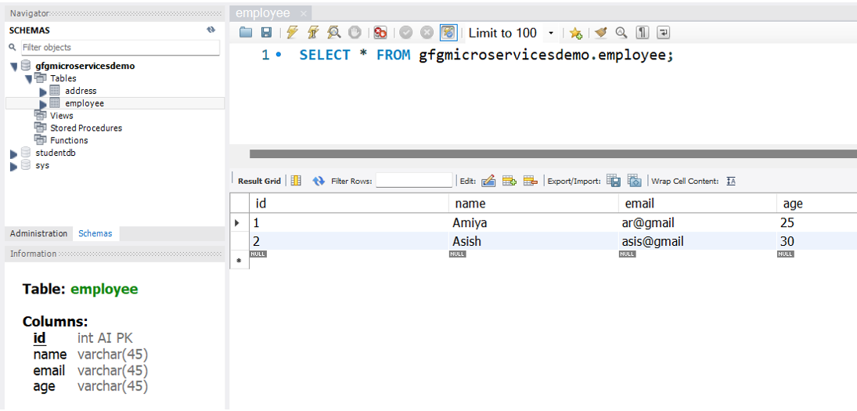

Now we are going to fetch Employee Data from Employee Table in our Spring Boot project. To do it refer to the following steps.

**Step 3: Make Changes in Your application.properties File**

Before moving to IntelliJ IDEA let’s have a look at the complete project structure for our Microservices.

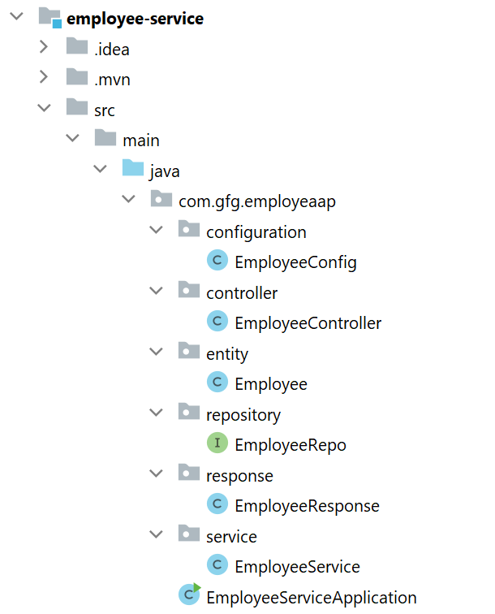

Now make the following changes in your [application.properties](https://www.geeksforgeeks.org/spring-boot-application-properties/) file.

spring.datasource.url=jdbc:mysql://localhost:3306/gfgmicroservicesdemo  
spring.datasource.username=put your username here  
spring.datasource.password=put your password here

You may also refer to the below image

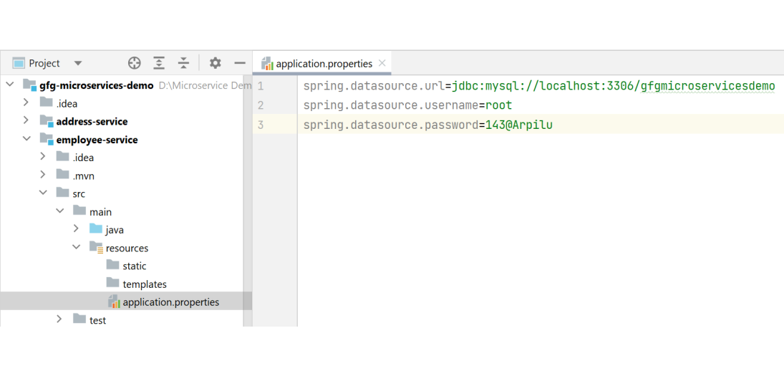

**Step 4: Create Your Entity/Model Class**

Go to the src > main > java > entity and create a class Employee and put the below code. This is our model class.

* Java

|  |
| --- |
| package com.gfg.employeaap.entity;    import jakarta.persistence.*;    @Entity  @Table(name = "employee")  public class Employee {        @Id      @GeneratedValue(strategy = GenerationType.IDENTITY)      @Column(name = "id")      private int id;        @Column(name = "name")      private String name;        @Column(name = "email")      private String email;        @Column(name = "age")      private String age;        public int getId() {          return id;      }        public void setId(int id) {          this.id = id;      }        public String getName() {          return name;      }        public void setName(String name) {          this.name = name;      }        public String getEmail() {          return email;      }        public void setEmail(String email) {          this.email = email;      }        public String getAge() {          return age;      }        public void setAge(String age) {          this.age = age;      }  } |

**Step 5: Create Your Repository Interface**

Go to the src > main > java > repository and create an interface EmployeeRepo and put the below code. This is our repository where we write code for all the database-related stuff.

* Java

|  |
| --- |
| package com.gfg.employeaap.repository;    import com.gfg.employeaap.entity.Employee;  import org.springframework.data.jpa.repository.JpaRepository;    public interface EmployeeRepo extends JpaRepository<Employee, Integer> {    } |

***Note****: Please refer to this article to know more about* [*JpaRepository*](https://www.geeksforgeeks.org/spring-boot-jparepository-with-example/)*.*

**Step 6: Create Your Service Class**

Go to the src > main > java > service and create a class EmployeeService and put the below code. This is our service class where we write our business logic.

* Java

|  |
| --- |
| package com.gfg.employeaap.service;    import com.gfg.employeaap.entity.Employee;  import com.gfg.employeaap.repository.EmployeeRepo;  import com.gfg.employeaap.response.EmployeeResponse;  import org.modelmapper.ModelMapper;  import org.springframework.beans.factory.annotation.Autowired;    import java.util.Optional;    public class EmployeeService {        @Autowired      private EmployeeRepo employeeRepo;        @Autowired      private ModelMapper mapper;        public EmployeeResponse getEmployeeById(int id) {          Optional<Employee> employee = employeeRepo.findById(id);          EmployeeResponse employeeResponse = mapper.map(employee, EmployeeResponse.class);          return employeeResponse;      }    } |

**Step 7: Create an EmployeeResponse Class**

Go to the src > main > java > response and create a class EmployeeResponse and put the below code.

* Java

|  |
| --- |
| package com.gfg.employeaap.response;    public class EmployeeResponse {        private int id;      private String name;      private String email;      private String age;        public int getId() {          return id;      }        public void setId(int id) {          this.id = id;      }        public String getName() {          return name;      }        public void setName(String name) {          this.name = name;      }        public String getEmail() {          return email;      }        public void setEmail(String email) {          this.email = email;      }        public String getAge() {          return age;      }        public void setAge(String age) {          this.age = age;      }  } |

**Step 8: Create an Employee Controller**

Go to the src > main > java > controller and create a class EmployeeController and put the below code. Here we are going to create an endpoint “***/employees/{id}***” to find an employee using id.

* Java

|  |
| --- |
| package com.gfg.employeaap.controller;    import com.gfg.employeaap.response.EmployeeResponse;  import com.gfg.employeaap.service.EmployeeService;  import org.springframework.beans.factory.annotation.Autowired;  import org.springframework.http.HttpStatus;  import org.springframework.http.ResponseEntity;  import org.springframework.web.bind.annotation.GetMapping;  import org.springframework.web.bind.annotation.PathVariable;  import org.springframework.web.bind.annotation.RestController;    @RestController  public class EmployeeController {        @Autowired      private EmployeeService employeeService;        @GetMapping("/employees/{id}")      private ResponseEntity<EmployeeResponse> getEmployeeDetails(@PathVariable("id") int id) {          EmployeeResponse employee = employeeService.getEmployeeById(id);          return ResponseEntity.status(HttpStatus.OK).body(employee);      }    } |

**Step 9: Create a Configuration Class**

Go to the src > main > java > configuration and create a class EmployeeConfig and put the below code.

* Java

|  |
| --- |
| package com.gfg.employeaap.configuration;    import com.gfg.employeaap.service.EmployeeService;  import org.modelmapper.ModelMapper;  import org.springframework.context.annotation.Bean;  import org.springframework.context.annotation.Configuration;    @Configuration  public class EmployeeConfig {        @Bean      public EmployeeService employeeBean() {          return new EmployeeService();      }        @Bean      public ModelMapper modelMapperBean() {          return new ModelMapper();      }    } |

***Note****: You may refer to these two articles*

* [*Spring @Configuration Annotation with Example*](https://www.geeksforgeeks.org/spring-configuration-annotation-with-example/)
* [*Spring @Bean Annotation with Example*](https://www.geeksforgeeks.org/spring-bean-annotation-with-example/)

Before running the Microservice below is the complete **pom.xml** file. Please cross-verify if you have missed some dependencies

* XML

|  |
| --- |
| <?xml version="1.0" encoding="UTF-8"?>  <project xmlns="<http://maven.apache.org/POM/4.0.0>"           xmlns:xsi="<http://www.w3.org/2001/XMLSchema-instance>"      xsi:schemaLocation="<http://maven.apache.org/POM/4.0.0>  <https://maven.apache.org/xsd/maven-4.0.0.xsd>">      <modelVersion>4.0.0</modelVersion>      <parent>          <groupId>org.springframework.boot</groupId>          <artifactId>spring-boot-starter-parent</artifactId>          <version>3.0.2</version>          <relativePath/> <!-- lookup parent from repository -->      </parent>      <groupId>com.gfg.employeaap</groupId>      <artifactId>employee-service</artifactId>      <version>0.0.1-SNAPSHOT</version>      <name>employee-service</name>      <description>Employee Service</description>      <properties>          <java.version>17</java.version>      </properties>      <dependencies>          <dependency>              <groupId>org.springframework.boot</groupId>              <artifactId>spring-boot-starter-data-jpa</artifactId>          </dependency>          <dependency>              <groupId>org.springframework.boot</groupId>              <artifactId>spring-boot-starter-web</artifactId>          </dependency>            <dependency>              <groupId>org.springframework.boot</groupId>              <artifactId>spring-boot-devtools</artifactId>              <scope>runtime</scope>              <optional>true</optional>          </dependency>          <dependency>              <groupId>com.mysql</groupId>              <artifactId>mysql-connector-j</artifactId>              <scope>runtime</scope>          </dependency>          <dependency>              <groupId>org.springframework.boot</groupId>              <artifactId>spring-boot-starter-test</artifactId>              <scope>test</scope>          </dependency>          <dependency>              <groupId>org.modelmapper</groupId>              <artifactId>modelmapper</artifactId>              <version>3.1.1</version>          </dependency>      </dependencies>        <build>          <plugins>              <plugin>                  <groupId>org.springframework.boot</groupId>                  <artifactId>spring-boot-maven-plugin</artifactId>              </plugin>          </plugins>      </build>    </project> |

**Step 10: Run Your Employee Microservice**

To run your Employee Microservice src > main > java > EmployeeServiceApplication and click on the Run button. If everything goes well then you may see the following screen in your console. Please refer to the below image.

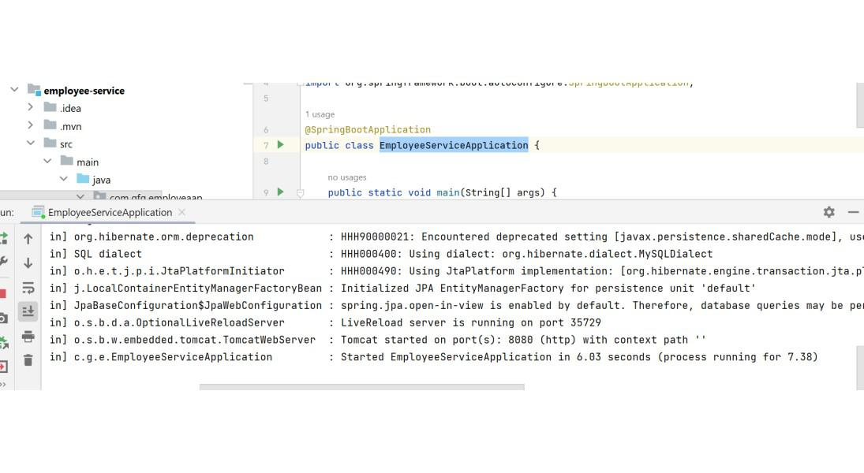

**Step 11: Test Your Endpoint in Postman**

Now open Postman and hit the following URL

GET: http://localhost:8080/employees/1

And you can see the following response

{  
 "id": 1,  
 "name": "Amiya",  
 "email": "ar@gmail",  
 "age": "25"  
}

Please refer to the below image.

